**Report “Lab 10”**

**Anton Tserakhau**

# Oracle Architecture - Parallel execution

I have created table BIG_TABLE:

CREATE TABLE big_table

AS

SELECT ROWNUM numb, 'row number ' || ROWNUM row_name

FROM DUAL

CONNECT BY LEVEL <= 1000000;

## Task 01: CREATE Example of Select Parallel execution

Amount of parallel: 1.

Select /*+ parallel(1)*/ count(*) from big_table;

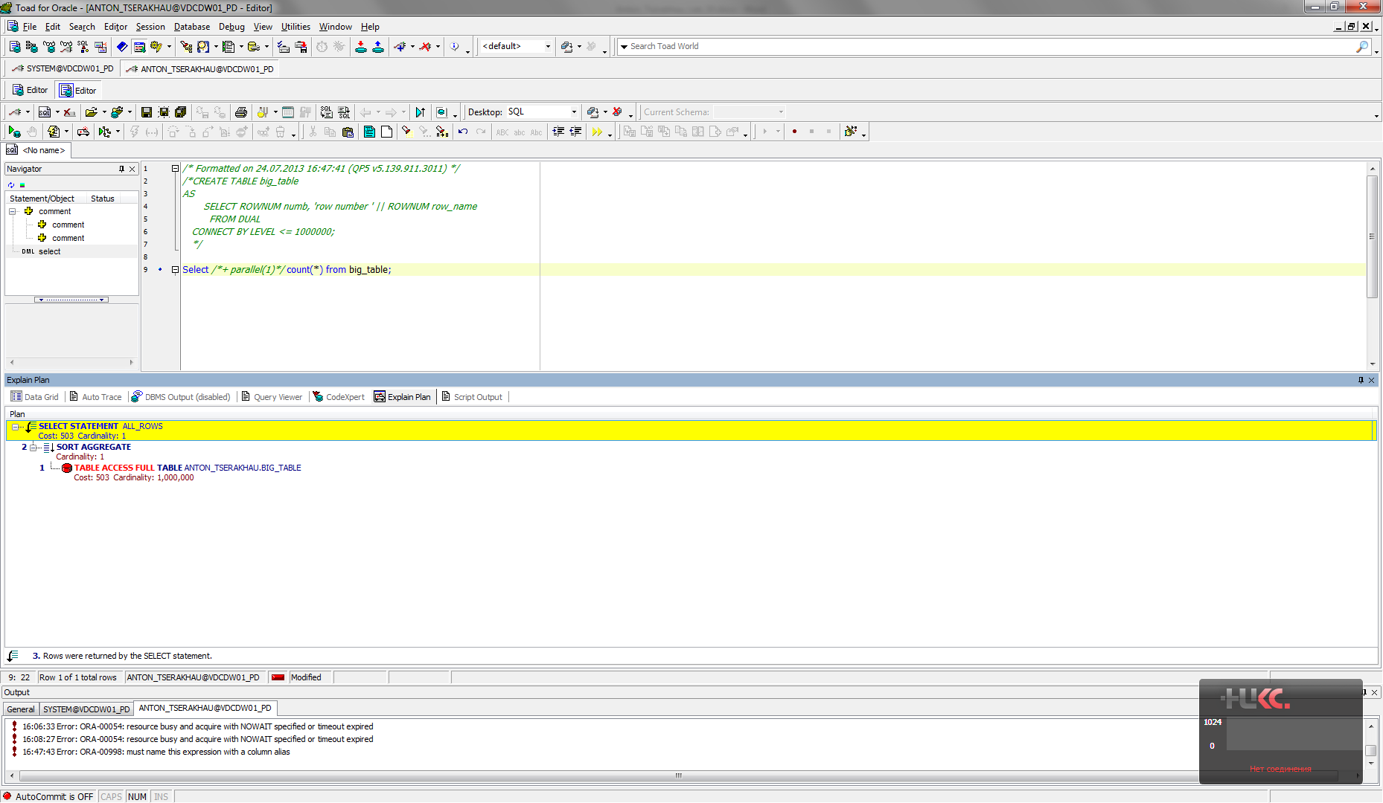

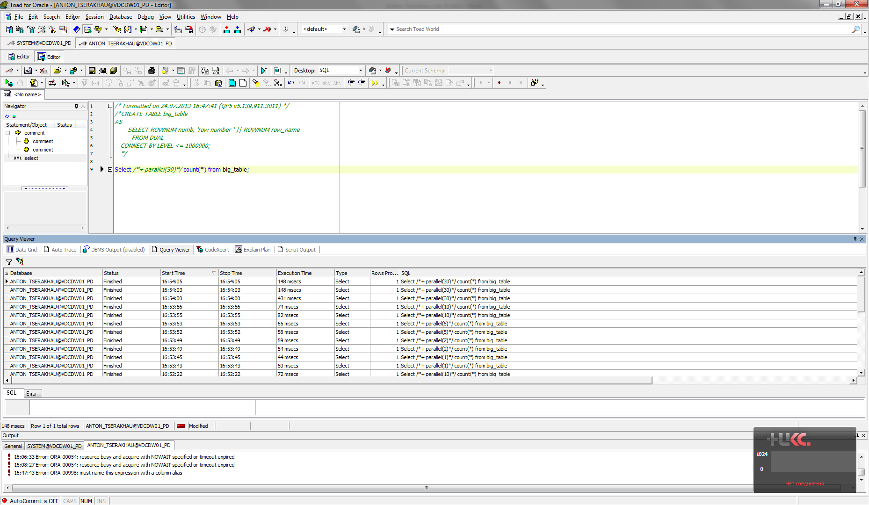

Amount of parallel: 2.

Select /*+ parallel(2)*/ count(*) from big_table;

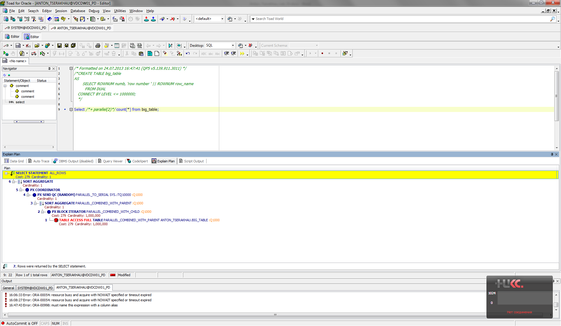



Amount of parallel: 5.

Select /*+ parallel(5)*/ count(*) from big_table;

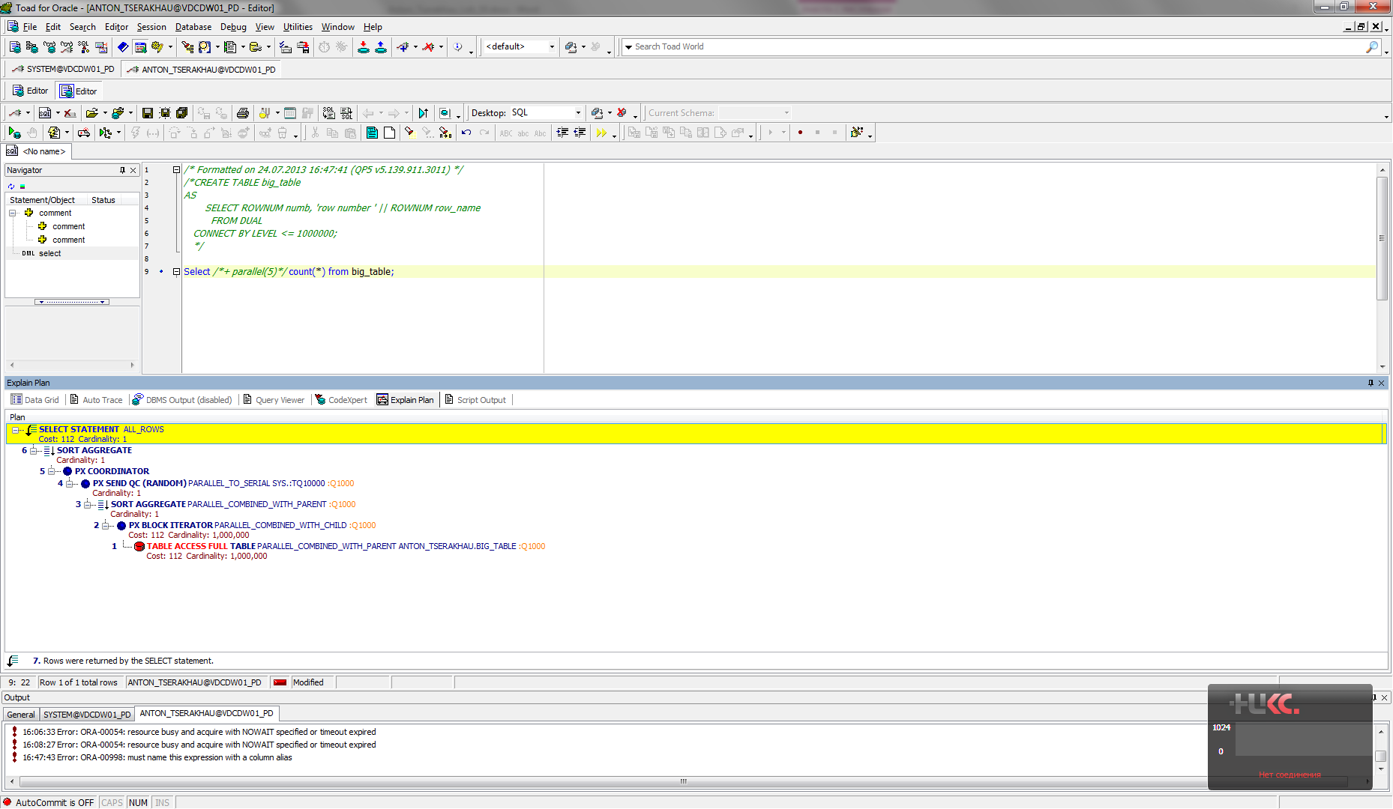



Amount of parallel: 10.

Select /*+ parallel(10)*/ count(*) from big_table;

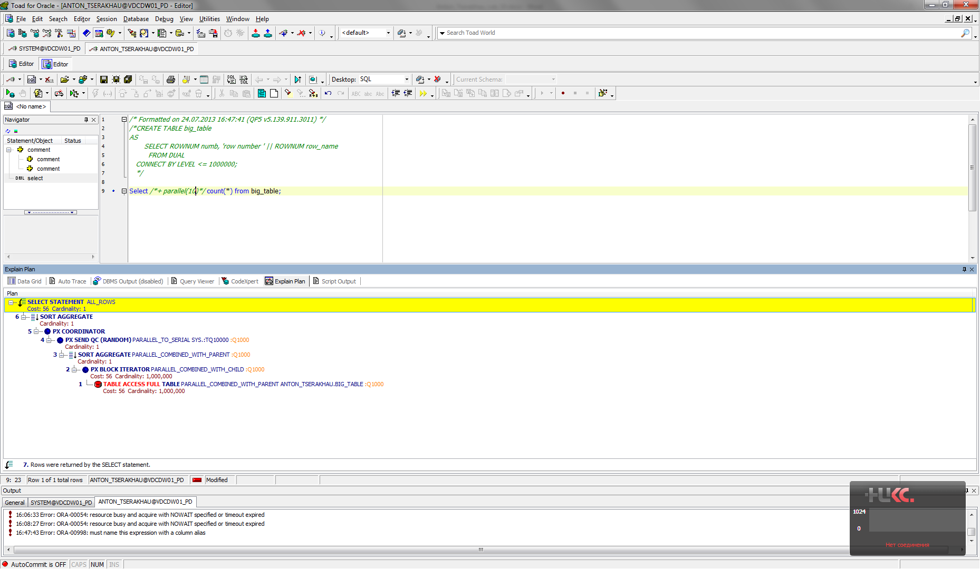



Amount of parallel: 30.

Select /*+ parallel(30)*/ count(*) from big_table;

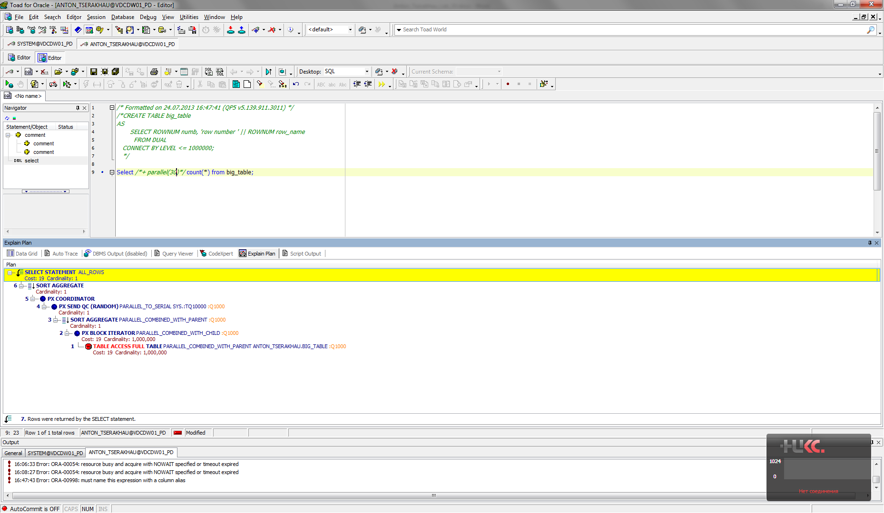



Summarize table:

|  |  |  |
| --- | --- | --- |
| **Amount of parallel process** | **Cost** | **Time** |
| 1 | 503 | 148 msecs |
| 2 | 279 | 74-82 msecs |
| 5 | 112 | 58-65 msecs |
| 10 | 56 | 54-59 msecs |
| 30 | 19 | 44-50 msecs |

## Task 02: CREATE Example of Parallel DML

Amount of parallel: 1.

UPDATE /*+ PARALLEL(1)*/ big_table SET row_name = row_name || ' :)';

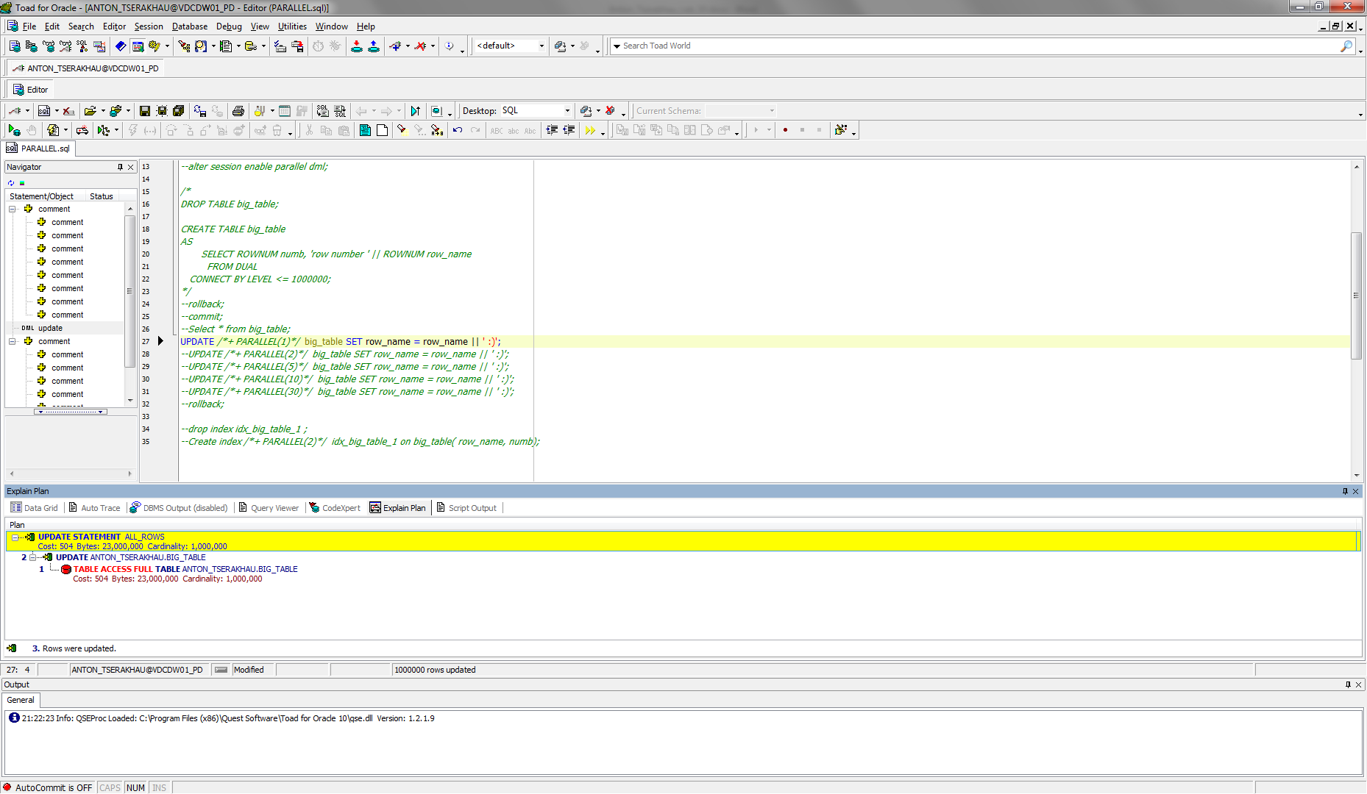

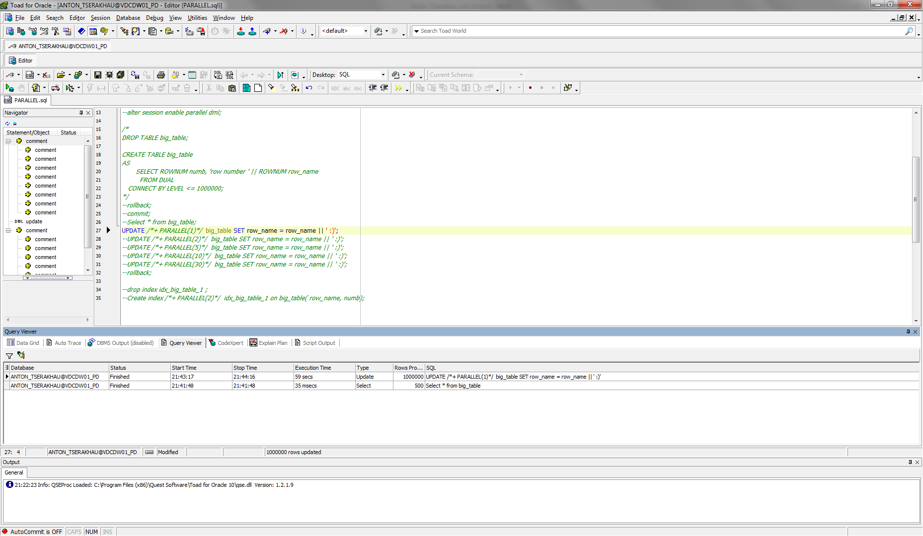

Amount of parallel: 2.

UPDATE /*+ PARALLEL(2)*/ big_table SET row_name = row_name || ' :)';

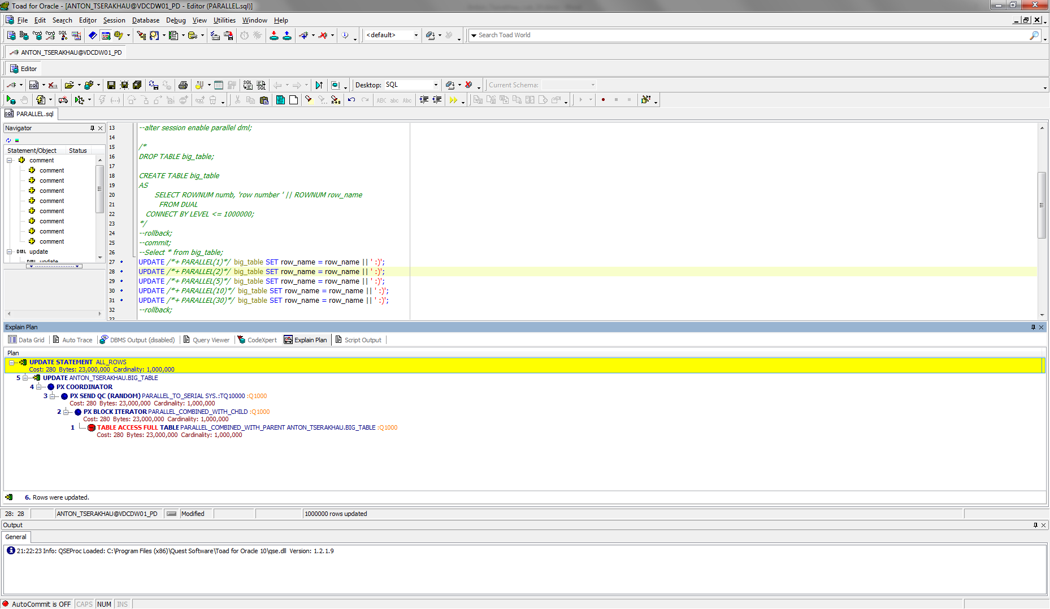

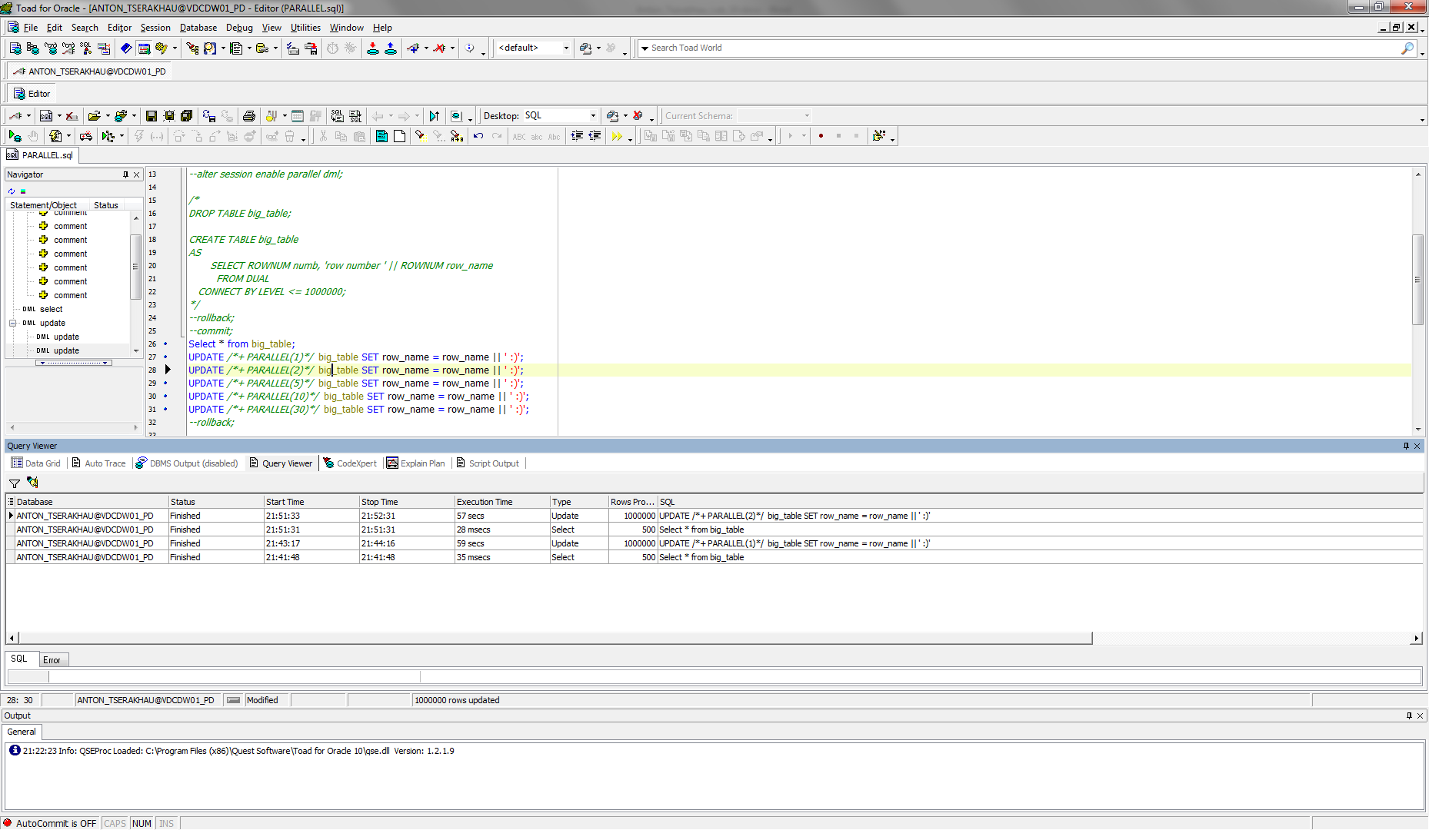

Amount of parallel: 5.

UPDATE /*+ PARALLEL(5)*/ big_table SET row_name = row_name || ' :)';

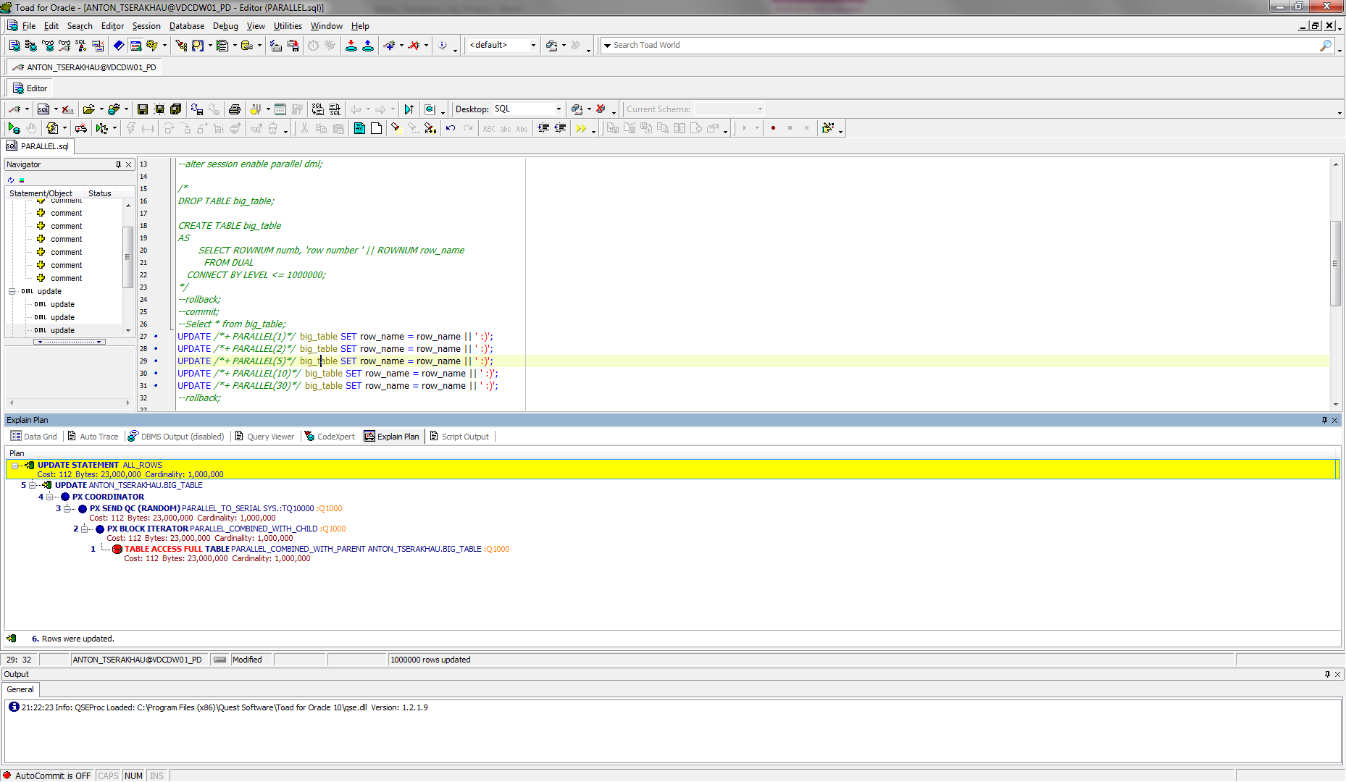

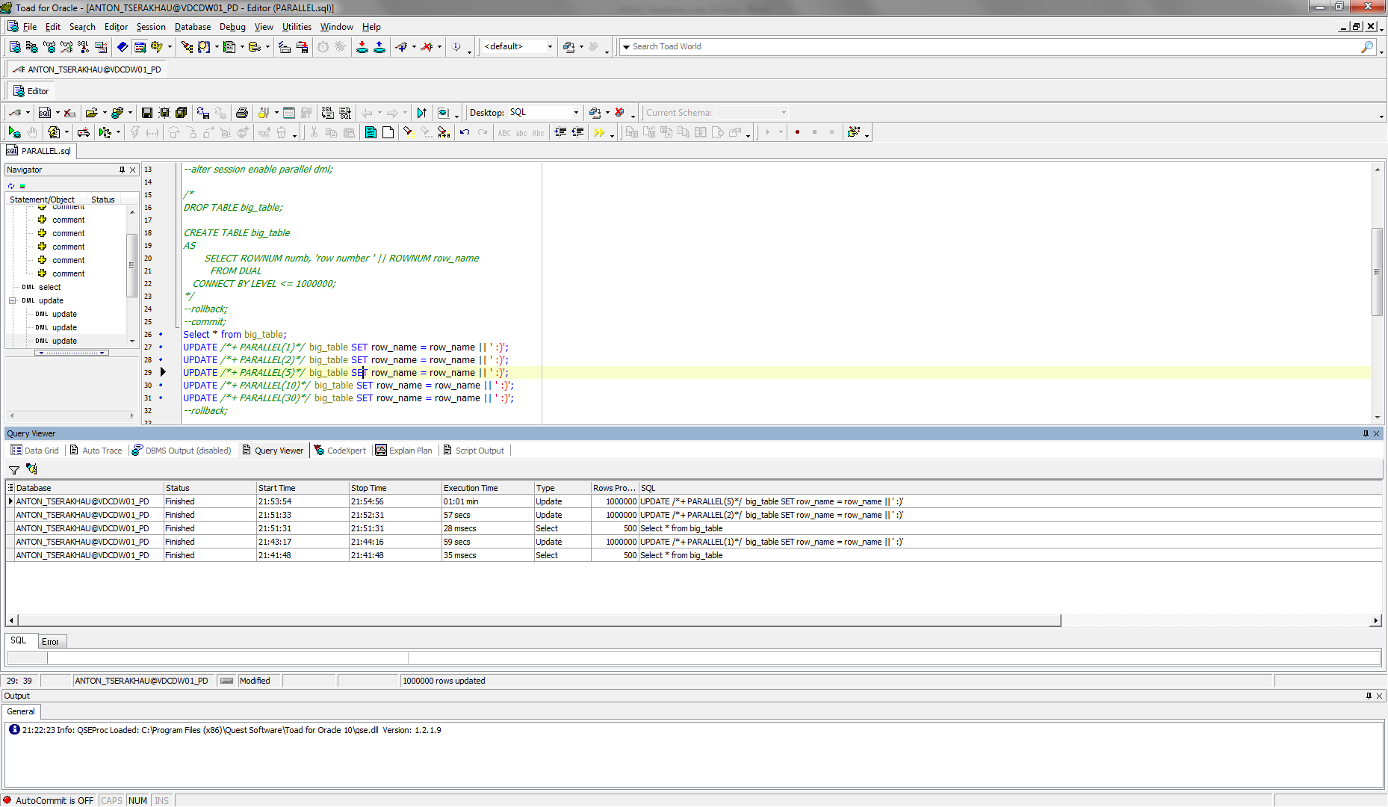

Amount of parallel: 10.

UPDATE /*+ PARALLEL(10)*/ big_table SET row_name = row_name || ' :)';

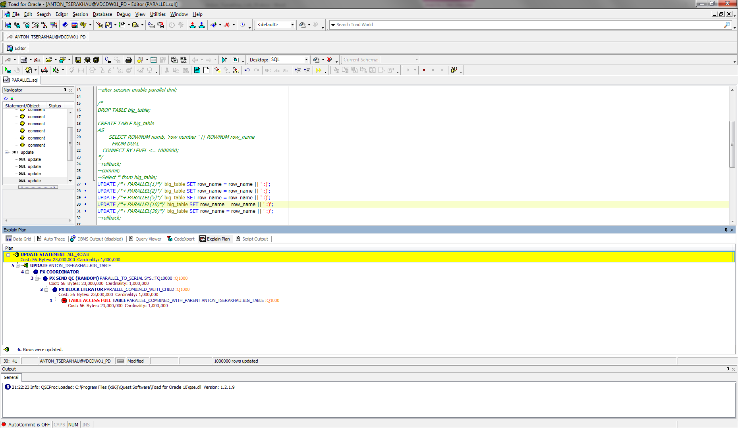

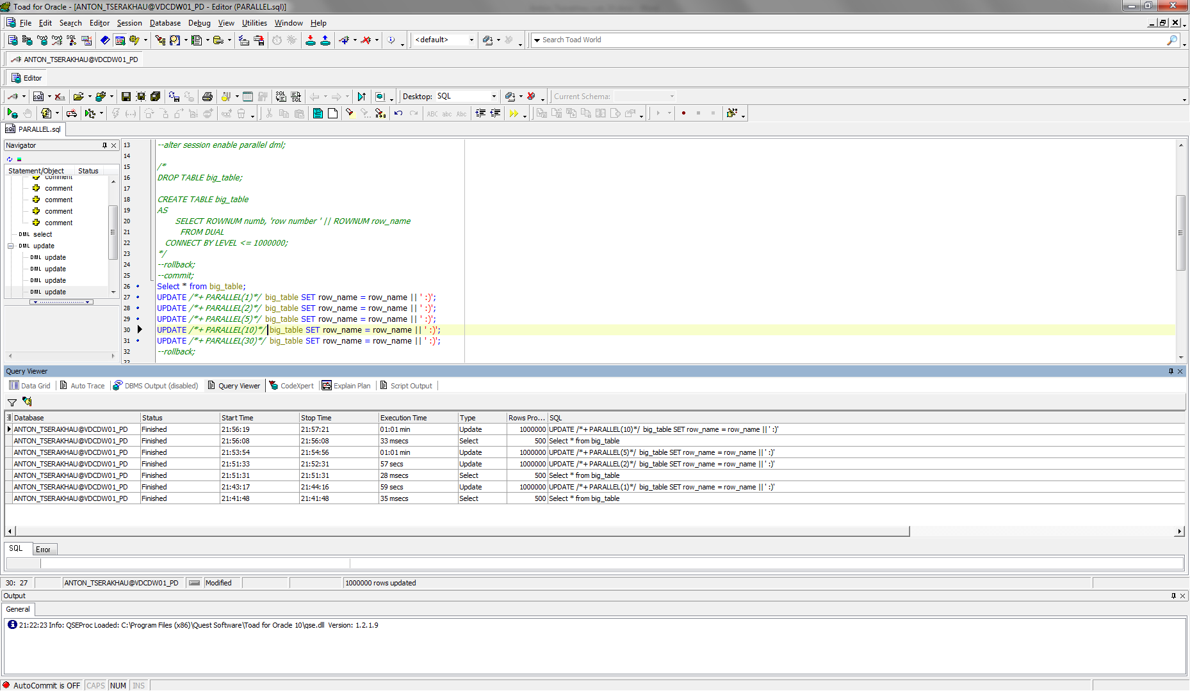

Amount of parallel: 30.

UPDATE /*+ PARALLEL(30)*/ big_table SET row_name = row_name || ' :)';

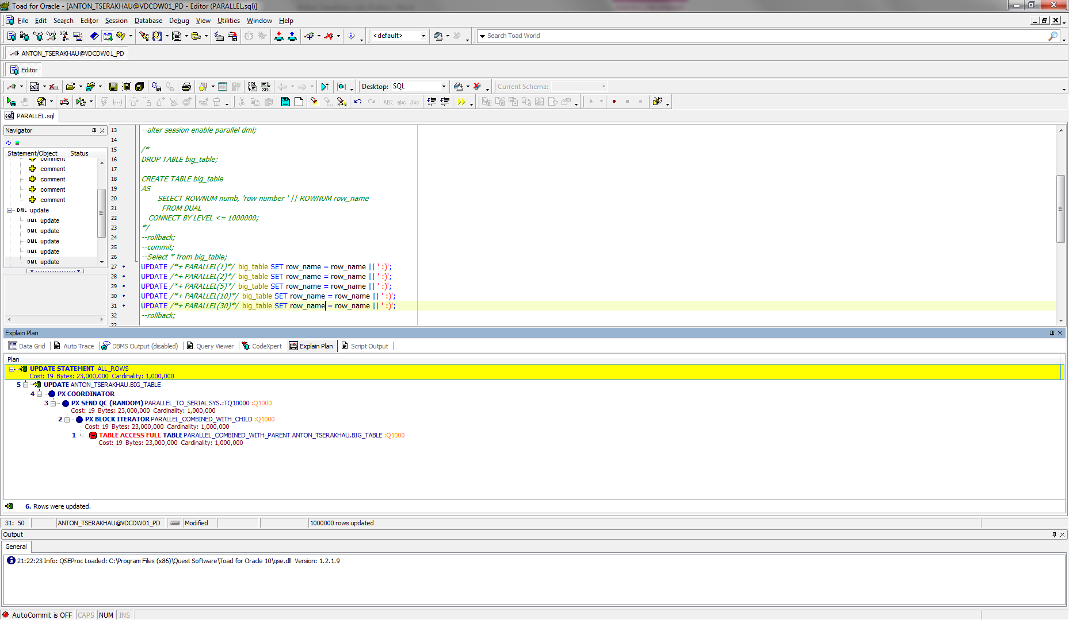

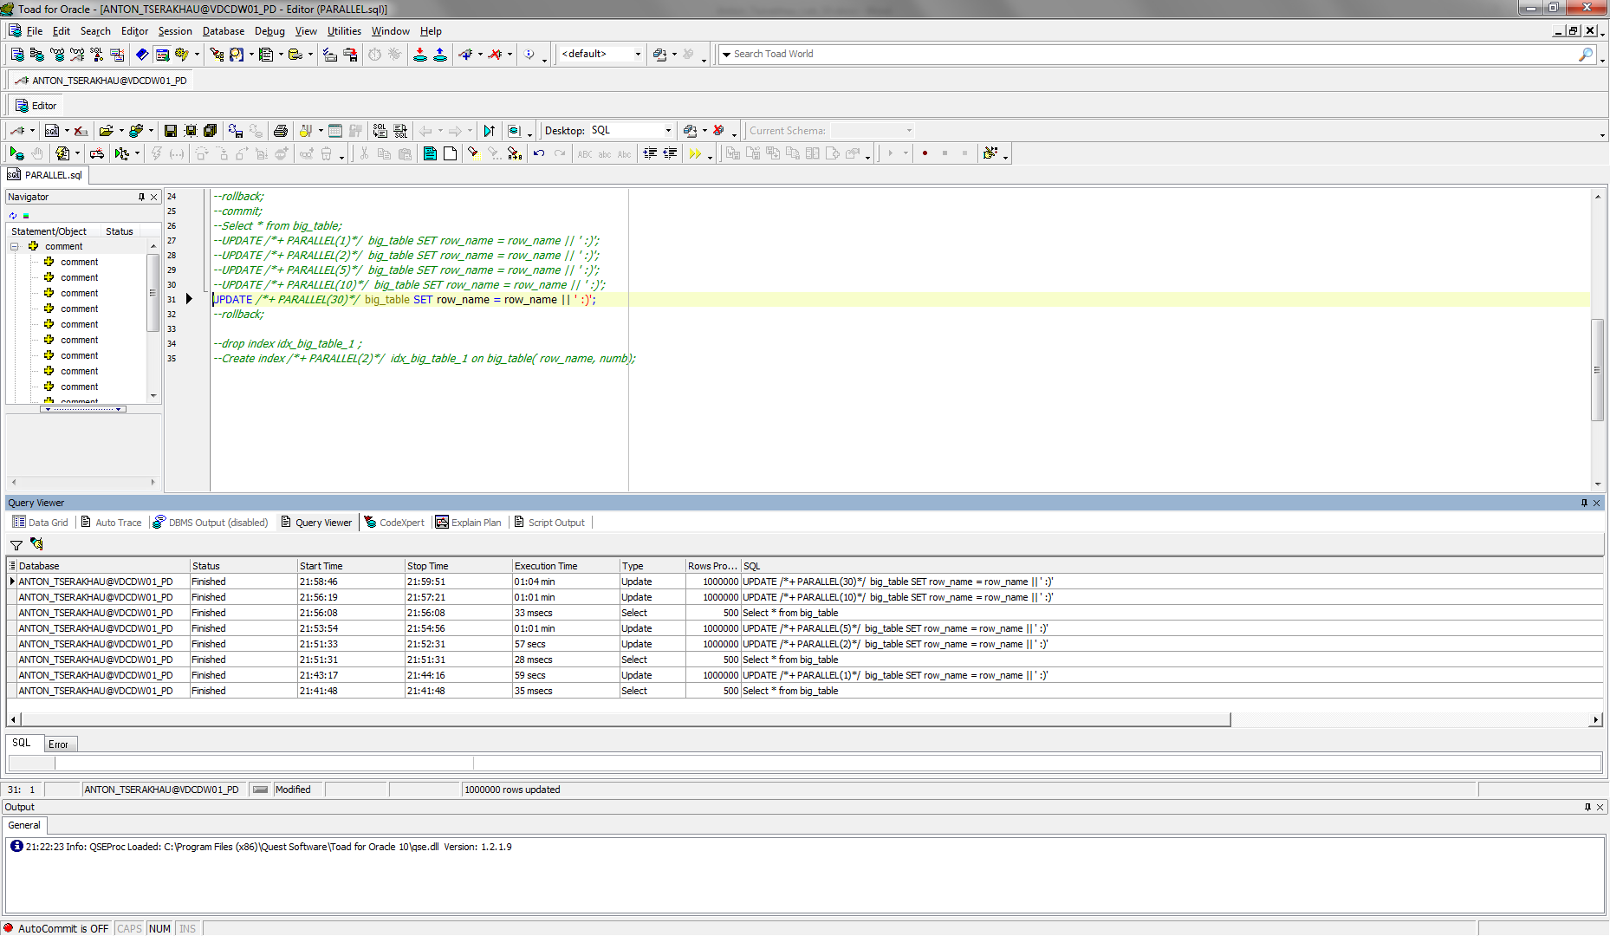

Summarize table

|  |  |  |
| --- | --- | --- |
| **Amount of parallel process** | **Cost** | **Time** |
| 1 | 504 | 59 secs |
| 2 | 280 | 57 secs |
| 5 | 112 | 61 secs |
| 10 | 56 | 61 secs |
| 30 | 19 | 64 secs |

## Task 03: CREATE Example of Parallel DDL

Amount of parallel: 1.

CREATE /*+ PARALLEL(1)*/ TABLE TEST_TABLE AS (SELECT T1.NUMB, T1.ROW_NAME, T2.ROW_NAME PREV_ROW_MAME FROM BIG_TABLE T1 LEFT JOIN BIG_TABLE T2 ON (T1.NUMB-1)=T2.NUMB);

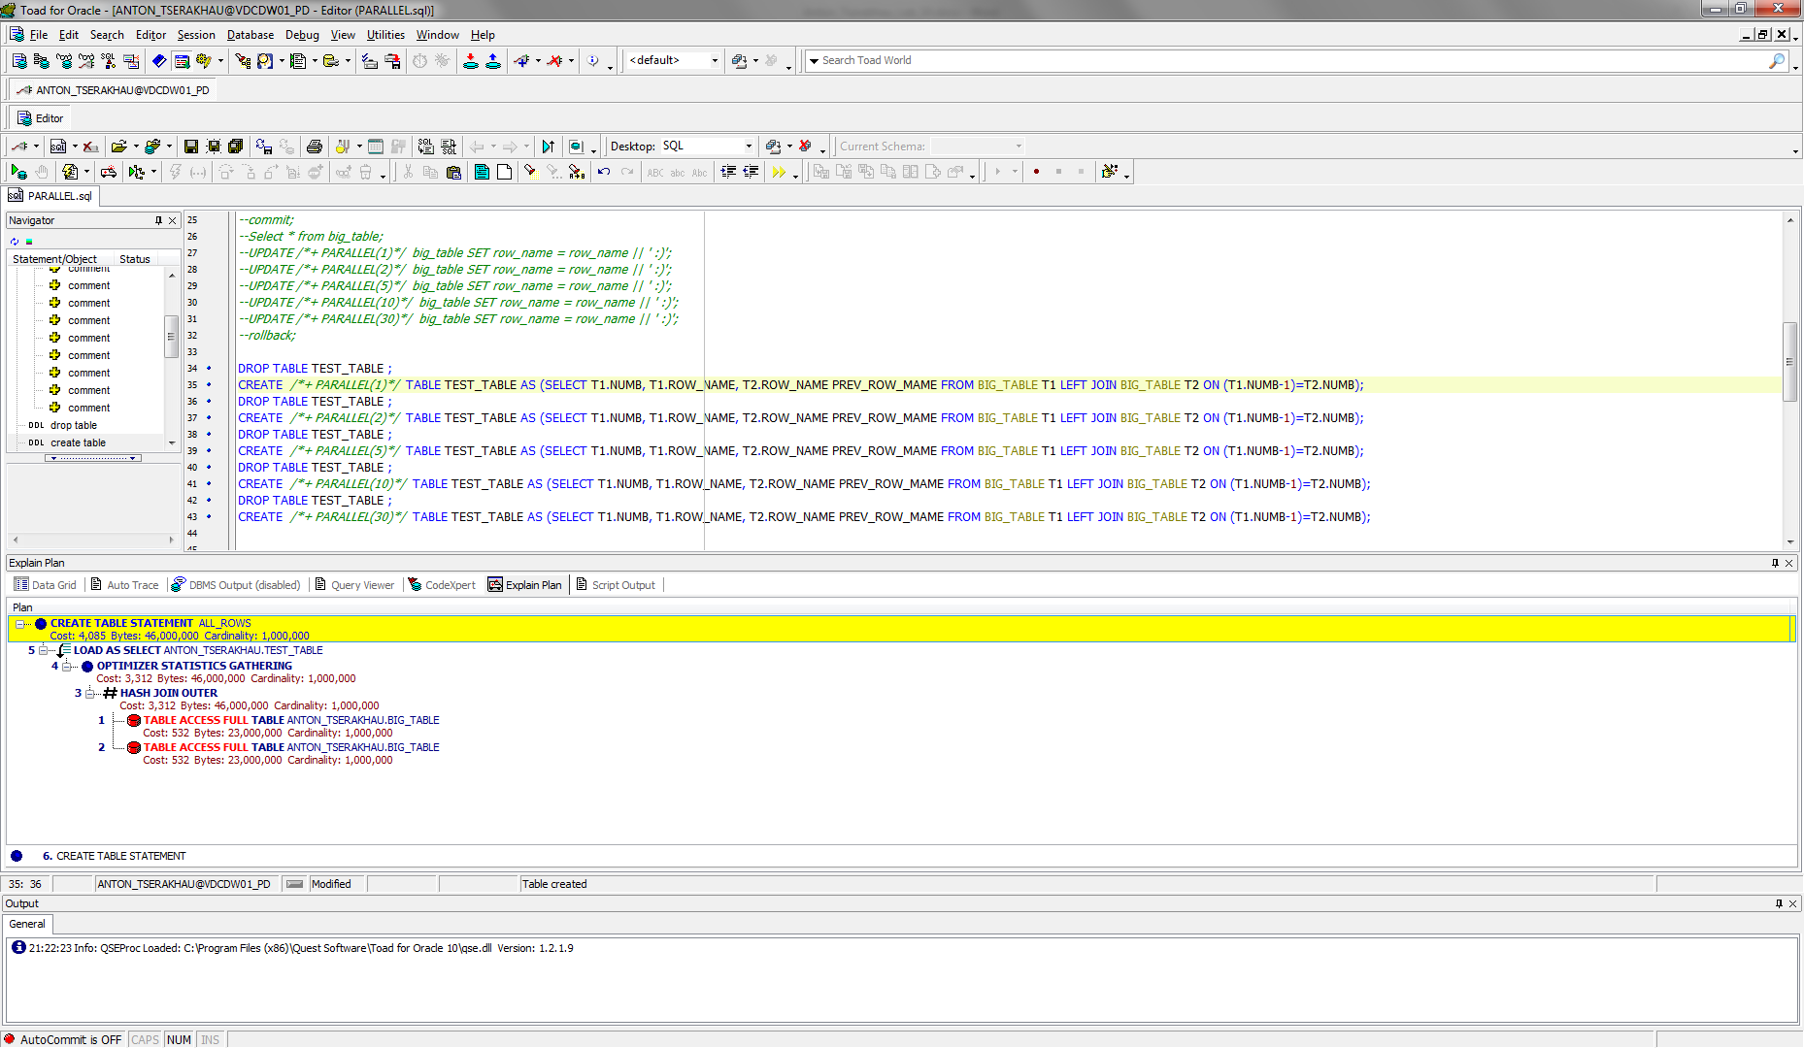

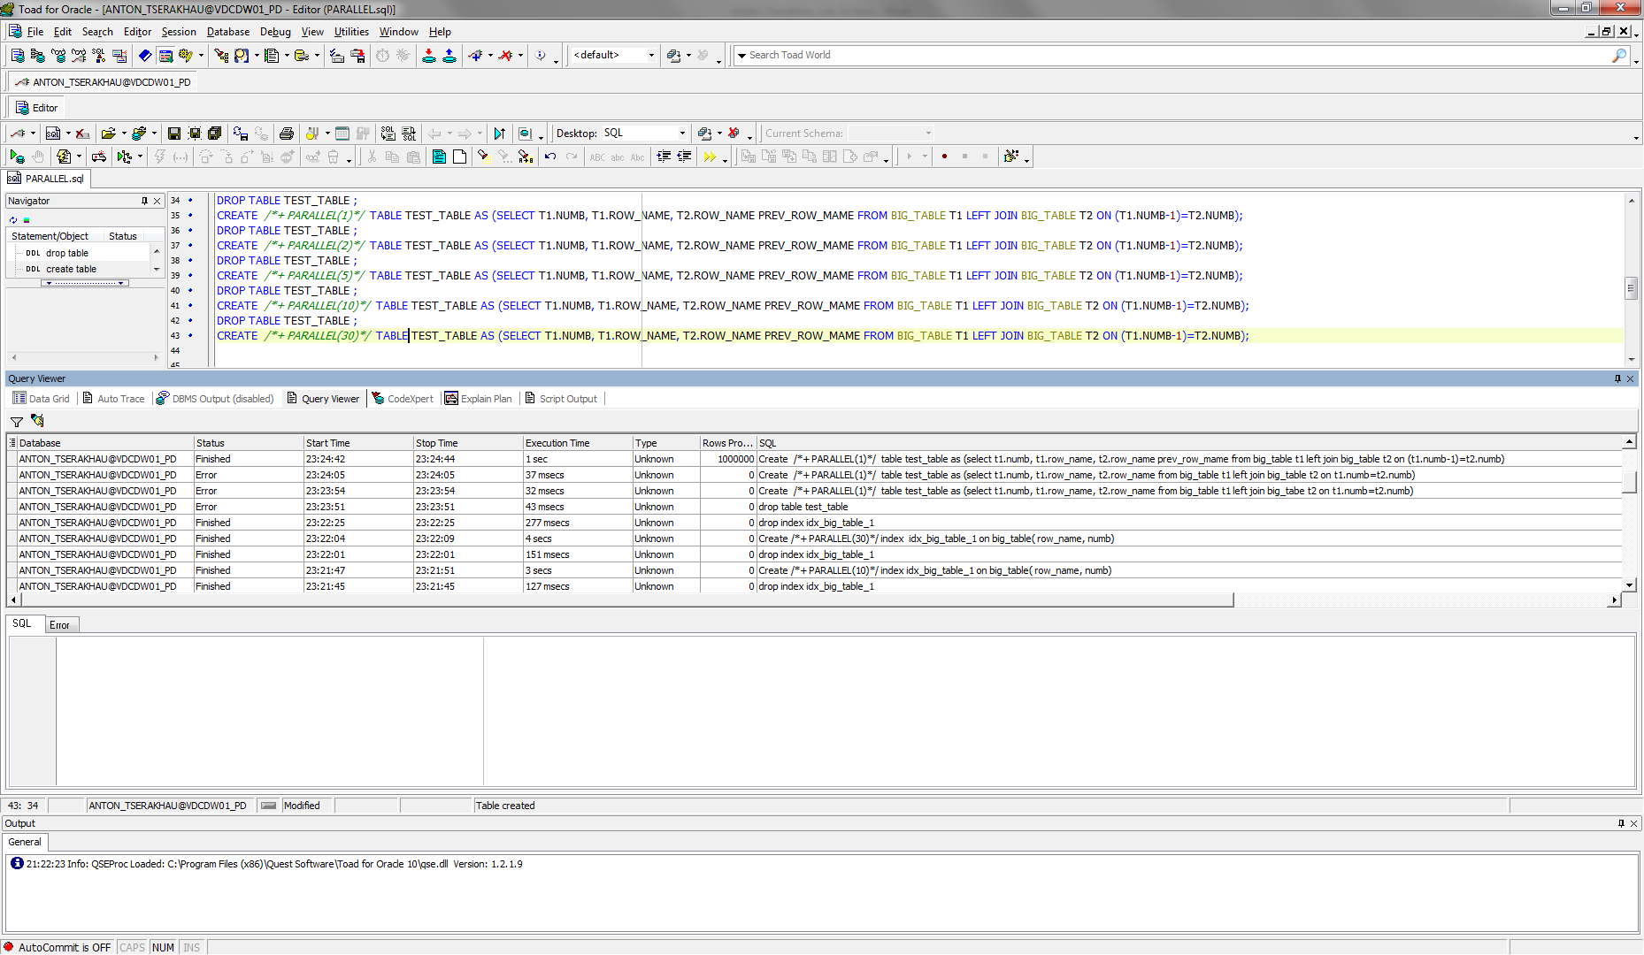

Amount of parallel: 2.

CREATE /*+ PARALLEL(2)*/ TABLE TEST_TABLE AS (SELECT T1.NUMB, T1.ROW_NAME, T2.ROW_NAME PREV_ROW_MAME FROM BIG_TABLE T1 LEFT JOIN BIG_TABLE T2 ON (T1.NUMB-1)=T2.NUMB);

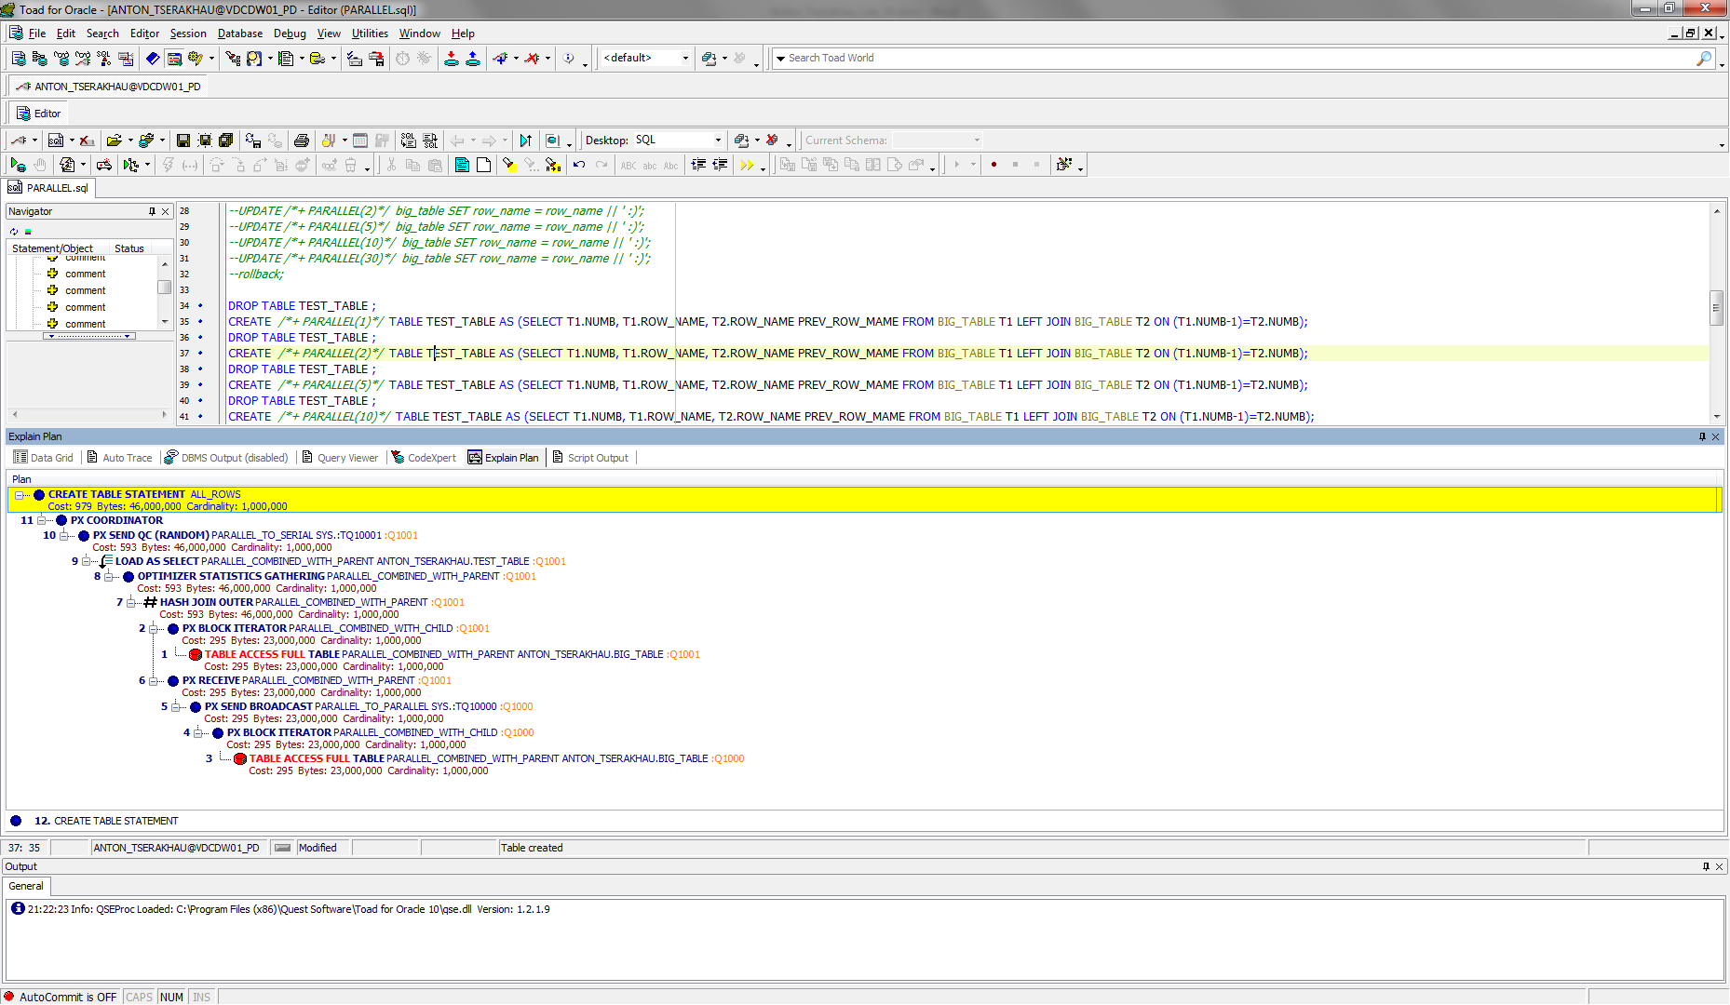

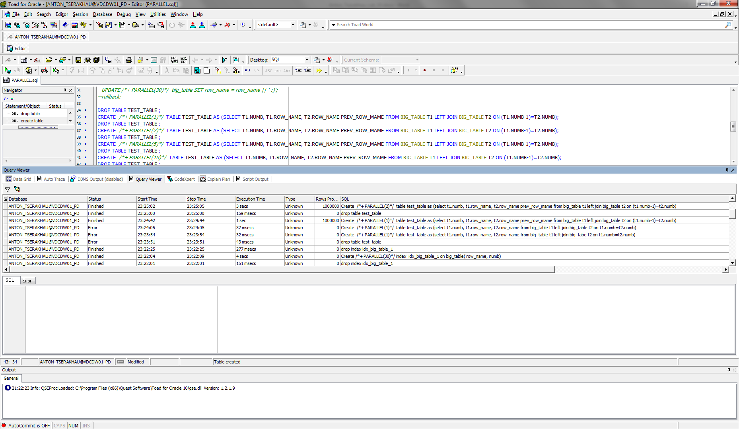

Amount of parallel: 5.

CREATE /*+ PARALLEL(5)*/ TABLE TEST_TABLE AS (SELECT T1.NUMB, T1.ROW_NAME, T2.ROW_NAME PREV_ROW_MAME FROM BIG_TABLE T1 LEFT JOIN BIG_TABLE T2 ON (T1.NUMB-1)=T2.NUMB);

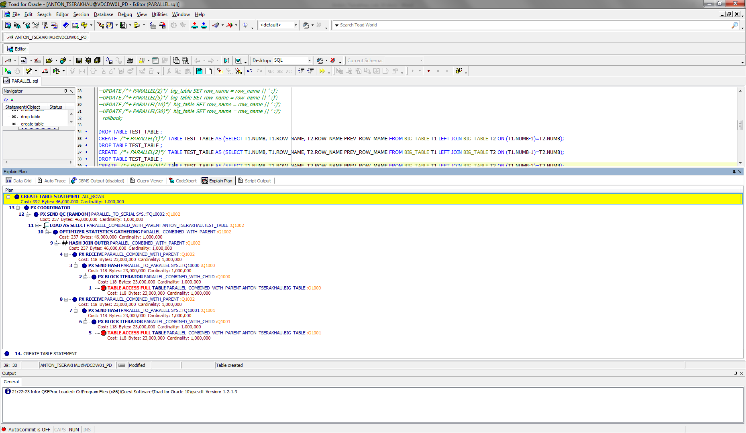

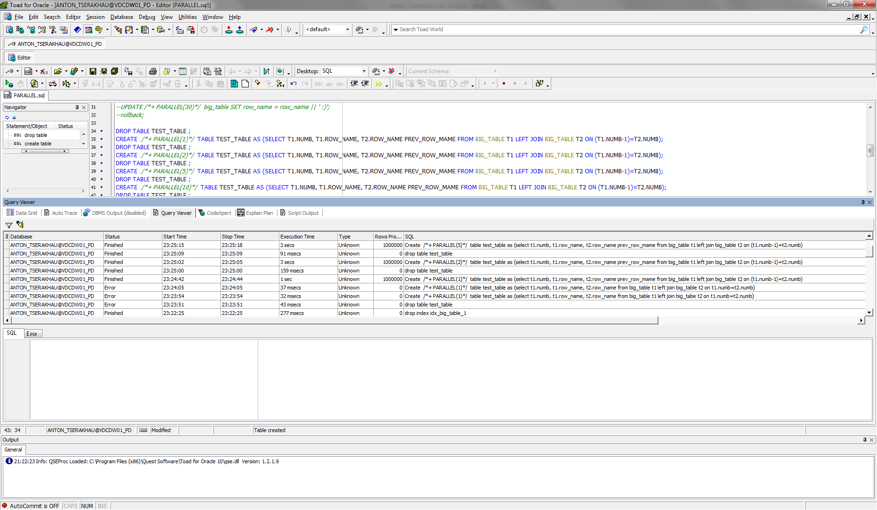

Amount of parallel: 10.

CREATE /*+ PARALLEL(10)*/ TABLE TEST_TABLE AS (SELECT T1.NUMB, T1.ROW_NAME, T2.ROW_NAME PREV_ROW_MAME FROM BIG_TABLE T1 LEFT JOIN BIG_TABLE T2 ON (T1.NUMB-1)=T2.NUMB);

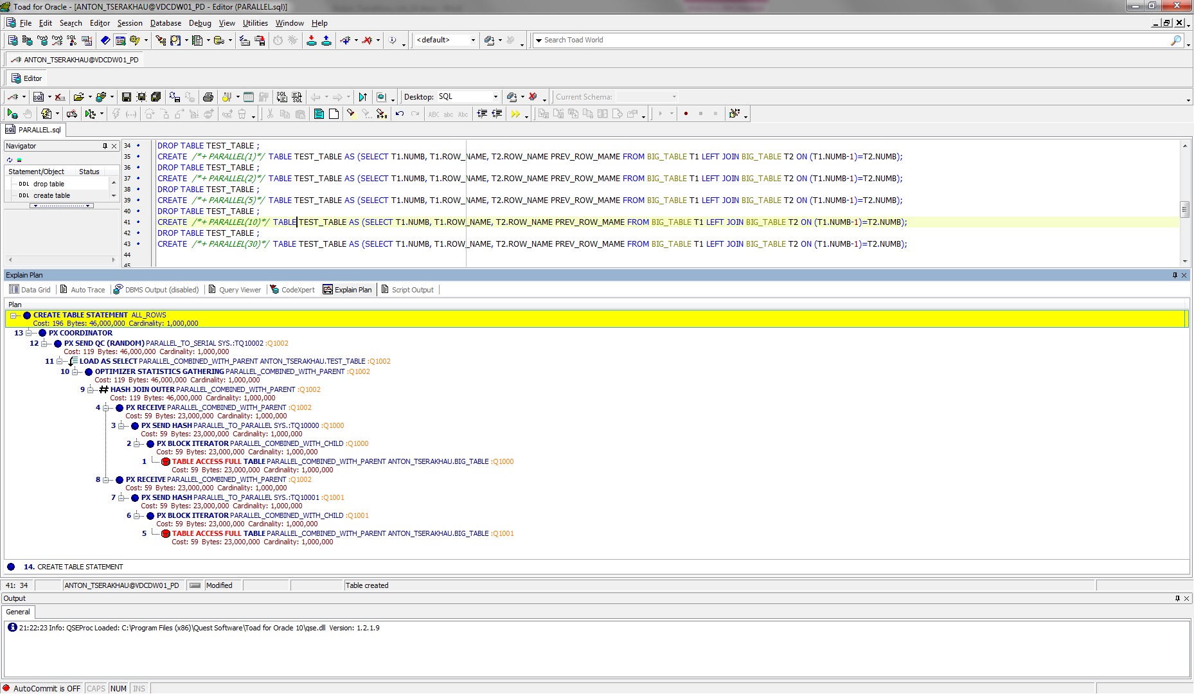

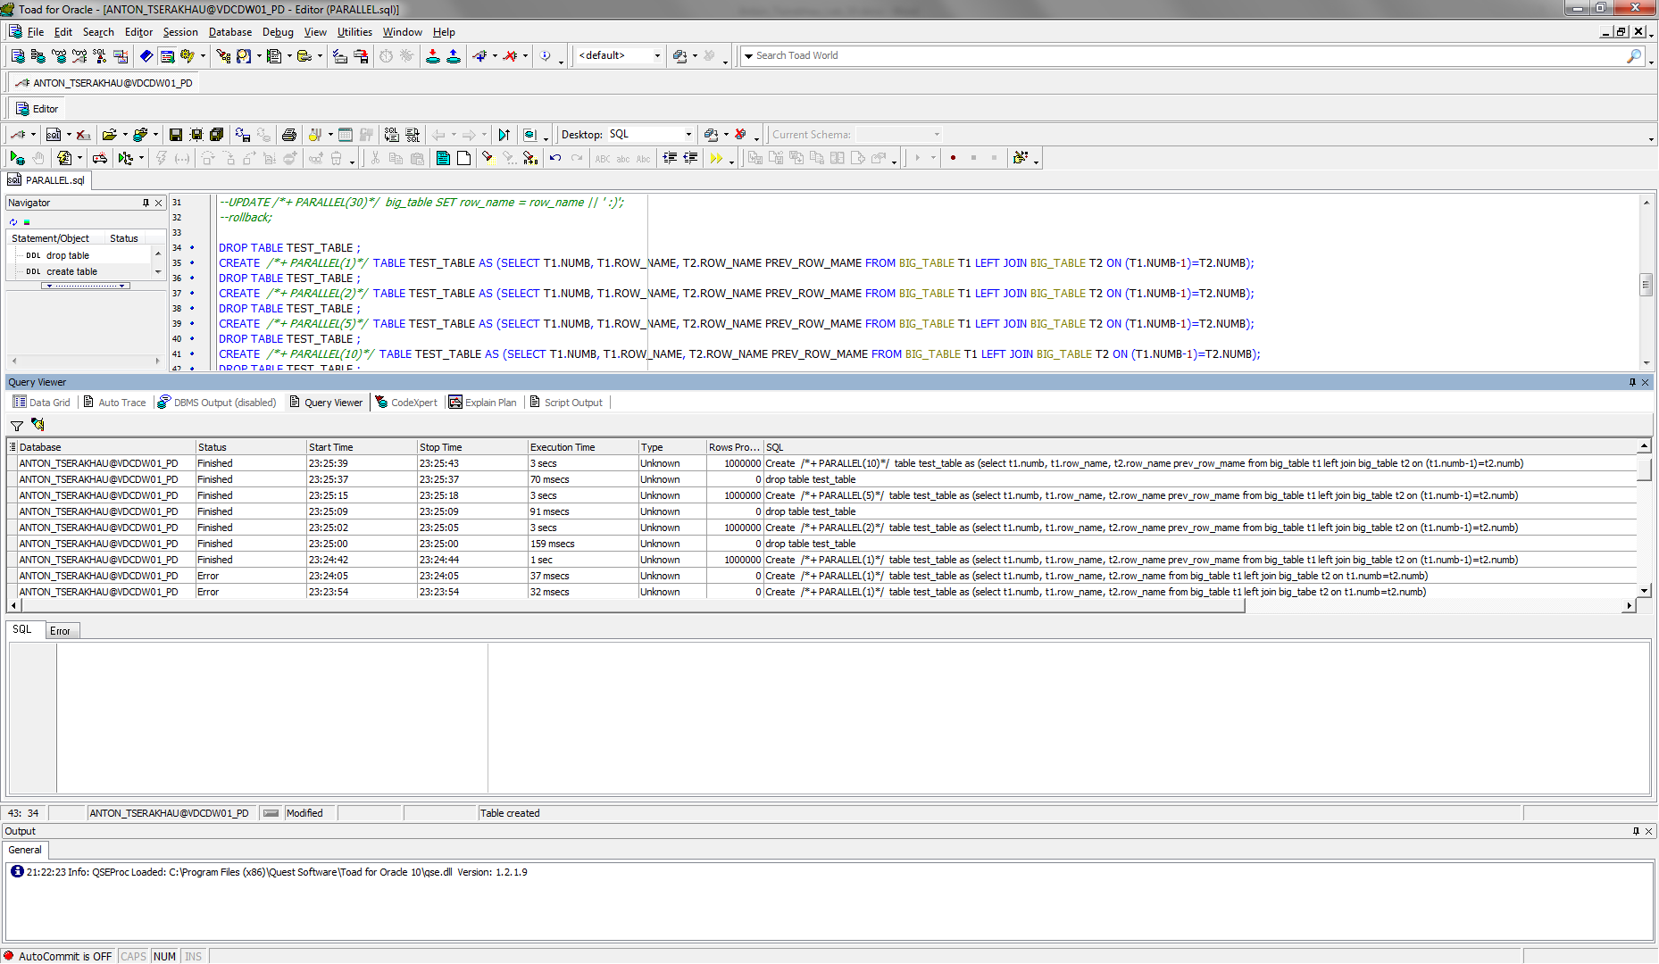

Amount of parallel: 30.

CREATE /*+ PARALLEL(30)*/ TABLE TEST_TABLE AS (SELECT T1.NUMB, T1.ROW_NAME, T2.ROW_NAME PREV_ROW_MAME FROM BIG_TABLE T1 LEFT JOIN BIG_TABLE T2 ON (T1.NUMB-1)=T2.NUMB);

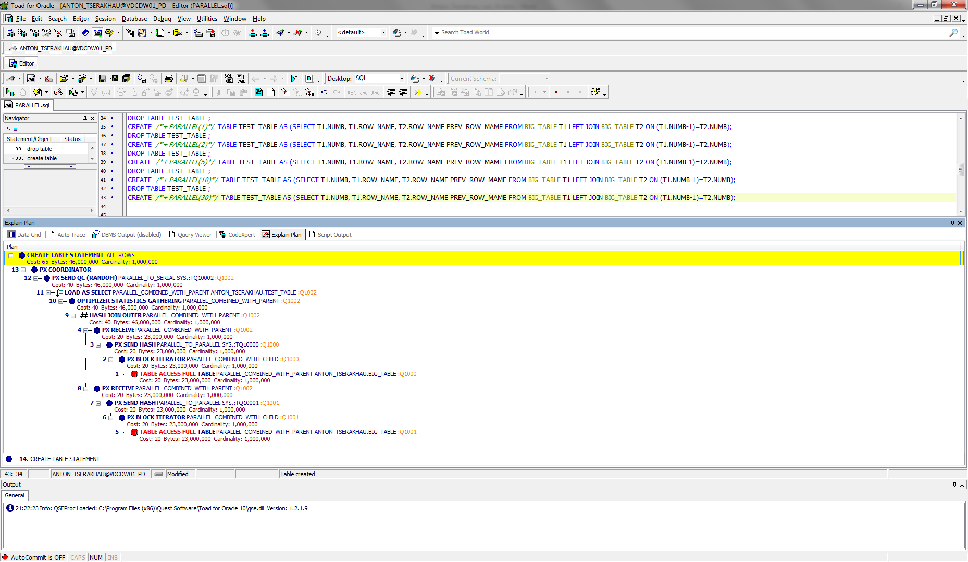

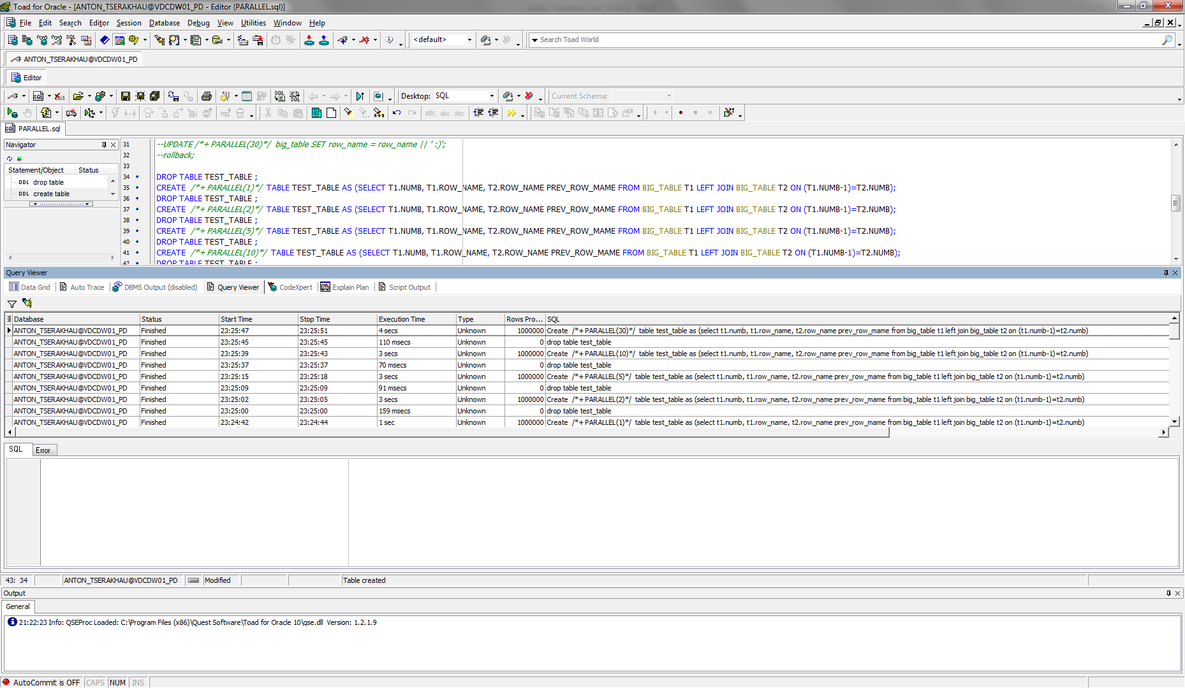

Summarize table

|  |  |  |
| --- | --- | --- |
| **Amount of parallel process** | **Cost** | **Time** |
| 1 | 4085 | 1 secs |
| 2 | 979 | 3 secs |
| 5 | 392 | 3 secs |
| 10 | 196 | 3 secs |
| 30 | 65 | 4 secs |